Project Planning Phase
Project Planning Template (Product Backlog, Sprint Planning, Stories, Story points)

Date | 18 October 2026
Team ID | Individual
Project Name | EV Market Performance & Sustainability Analytics Dashboard
Maximum Marks | 8 Marks

Product Backlog, Sprint Schedule, and Estimation (4 Marks)
Use the below template to create product backlog and sprint schedule
Sprint | Functional Requirement (Epic) | User Story Number | User Story / Task | Story Points | Priority | Team Members
Sprint-1 | Data Access & Integration | USN-1 | As an analyst, I can connect the EV market CSV dataset to Tableau so that I can analyze vehicle and sales data. | 3 | High | Individual
Sprint-1 | Data Processing | USN-2 | As an analyst, I can check data types and missing values so that dashboard metrics are reliable. | 3 | High | Individual
Sprint-1 | KPI Analysis | USN-3 | As a manager, I can view total sales, average price, average range, and annual CO₂ savings. | 3 | High | Individual
Sprint-1 | Sales Analysis | USN-4 | As a strategy director, I can view EV sales trends by model year and vehicle category. | 3 | High | Individual
Sprint-2 | Geographical Analysis | USN-5 | As a business intelligence manager, I can compare EV sales across manufacturing countries. | 2 | High | Individual
Sprint-2 | Battery Analysis | USN-6 | As a researcher, I can compare battery technology distribution and sales contribution. | 2 | Medium | Individual
Sprint-2 | Manufacturer Analysis | USN-7 | As a manager, I can identify top manufacturers by sales and customer rating. | 2 | High | Individual
Sprint-2 | Interactive Dashboard | USN-8 | As a dashboard user, I can filter by year, country, category, battery type, and region. | 2 | High | Individual

Project Tracker, Velocity & Burndown Chart: (4 Marks)
Sprint | Total Story Points | Duration | Sprint Start Date | Sprint End Date (Planned) | Story Points Completed (as on Planned End Date) | Sprint Release Date (Actual)
Sprint-1 | 20 | 6 Days | 27 Oct 2026 | 01 Nov 2026 | 20 | 01 Nov 2026
Sprint-2 | 20 | 6 Days | 02 Nov 2026 | 07 Nov 2026 | 20 | 07 Nov 2026
Sprint-3 | 20 | 6 Days | 08 Nov 2026 | 13 Nov 2026 | 20 | 13 Nov 2026
Sprint-4 | 20 | 6 Days | 14 Nov 2026 | 19 Nov 2026 | 20 | 19 Nov 2026

Velocity:
Assume a 10-day sprint with 20 story points completed. Average team velocity per day = Total story points completed ÷ Sprint duration = 20 ÷ 10 = 2 story points per day.


Burndown Chart:
A burn down chart is a graphical representation of work left to do versus time. It is often used in agile software development methodologies such as Scrum. However, burn down charts can be applied to any project containing measurable progress over time.
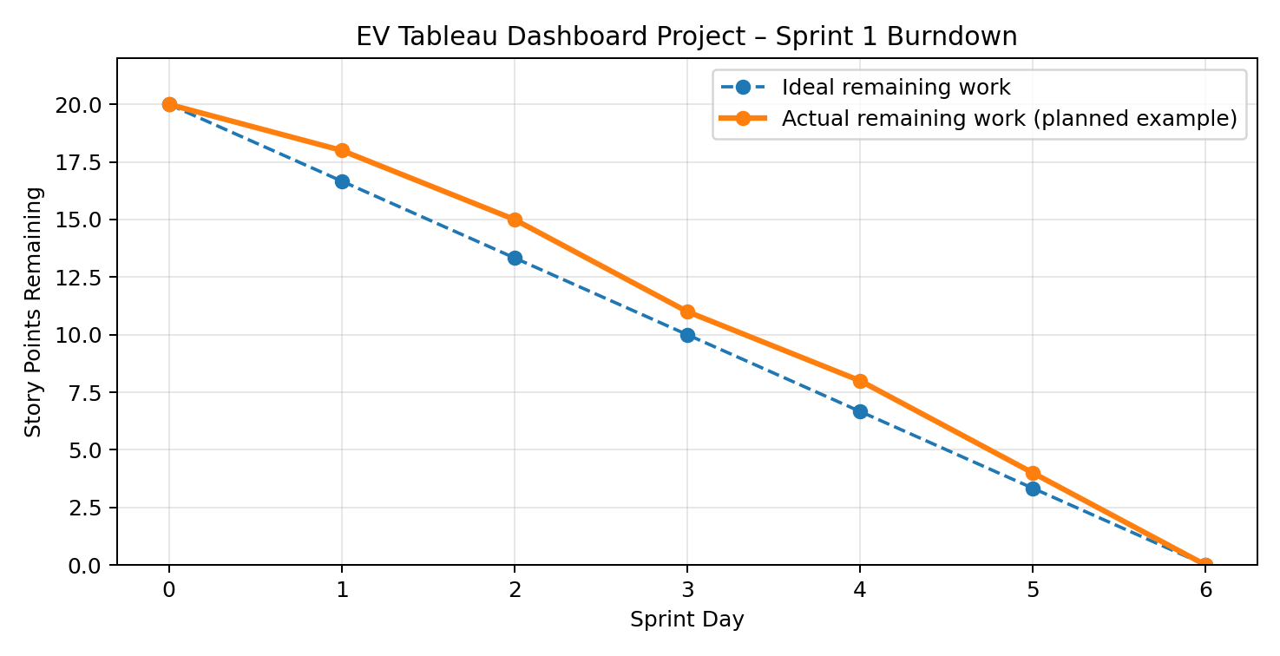
Figure: Illustrative burndown chart for a 6-day sprint (20 story points).

https://www.visual-paradigm.com/scrum/scrum-burndown-chart/
https://www.atlassian.com/agile/tutorials/burndown-charts

Reference:
https://www.atlassian.com/agile/project-management
https://www.atlassian.com/agile/tutorials/how-to-do-scrum-with-jira-software
https://www.atlassian.com/agile/tutorials/epics
https://www.atlassian.com/agile/tutorials/sprints
https://www.atlassian.com/agile/project-management/estimation
https://www.atlassian.com/agile/tutorials/burndown-charts

